WEB TECHNOLOGIES LAB

.

WEB TECHNOLOGIES LABORATORY

OBJECTIVE:

Presenting information over internet in form of web pages is the best way of reaching to all corners of world. This laboratory aims at giving knowledge about creating web pages and also about different web programming concepts, technologies.
OUTCOMES:

Upon the completion of Web Technologies practical course, the student will be able to:
- Able to develop web sites based on client side and server side technologies like HTML, Java Script, AJAX, PHP, Servlets and JSPs.
- Ability to create XML documents and able to retrieve/store in database.

EXPERIMENT-1

1.1 OBJECTIVE:
To Install XAMPP Stack Server.
1.2 RESOURCES:
XAMPP Stack Software, 1GB RAM, Hard Disk 80 GB.
1.3 PROCEDURE:
1. Run the XAMPP setup software.
2. In the next Screen, Select the path if required and then click on the Next Button.

3. In the next screen select Apache and MySQL. You may optionally select FileZilla (FTP
Client) if needed. Click Install.

4. On successful completion of installation, the following window will appear.
5. Click on Finish button.
1.4 INPUT AND OUTPUT:

EXECUTED OUTPUT

1.5 PRE LAB VIVA QUESTIONS:
1. What is setup file?
2. What is client side scripting?
3. What is server side scripting?
4. What is Mysql?
5. What is the usage of apache tomcat server?
6. How to run the PHP file?

EXPERIMENT-2

2.1 OBJECTIVE:
Write an HTML page including JavaScript that takes a given set of integer number shows them after sorting in descending order.
2.2 PROGRAM LOGIC:
1. Create a HTML file.
2. Read a number in one text field and display the numbers sorting in descending order.
3. Include the JavaScript to display sorted numbers in descending order.
2.3 PROCEDURE:
To execute a PHP program:
1. Open XAMPP control Panel then start Apache Server and Mysql.
2. Open Notepad and Save the html program in htdocs folder of XAMPP.
3. To run the html file open the browser and type the following URL
http://localhost:8086/directoryname/filename.
  - SOURCE CODE:
Sort.html
<!DOCTYPE html>
<html>
<body>
<h2>JavaScript Array Sort</h2>
<p>Click the button to sort the array in descending order.</p>
<button onclick="myFunction()">Try it</button>
<p id="sort"></p>
<script>
var points = [40, 100, 1, 5, 25, 10];
document.getElementById("sort").innerHTML = points;

function myFunction() {
points.sort(function(b, a){return a - b});
document.getElementById("sort").innerHTML = points;
}
</script></body>
</html>

2.5 INPUT AND OUTPUT:
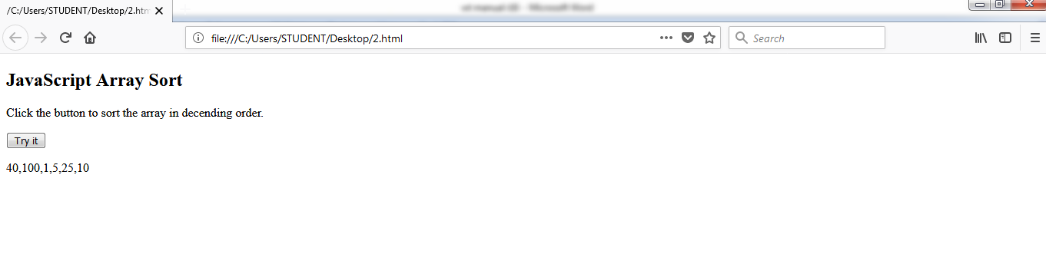

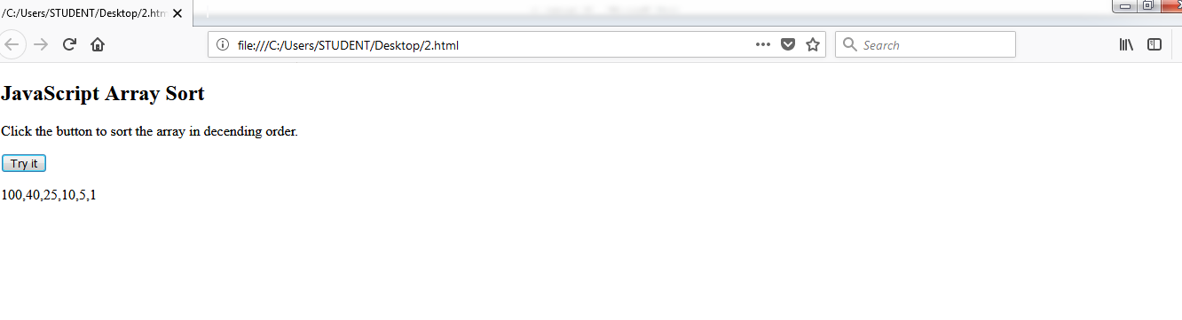

EXECUTED OUTPUT

  - LAB VIVA QUESTIONS

- What is JavaScript?
- What is an array?

EXPERIMENT-3
3.1 OBJECTIVE:
To accept a number from one text field in the range of 0 to 999 and shows it in another
text field in words. If the number is out of range, it should show “out of range” and if it is
not a number, it should show “not a number” message in the result box.
3.2 PROGRAM LOGIC:
1. Create a HTML file.
2. Read a number in one text field and display that number name in another text field.
3. Include the JavaScript to display valid range of numbers.
3.3 PROCEDURE:
To execute a PHP program:
1. Open XAMPP control Panel then start Apache Server and Mysql.
2. Open Notepad and Save the html program in htdocs folder of XAMPP.
3. To run the html file open the browser and type the following URL
http://localhost:8086/directoryname/filename.
3.4 SOURCE CODE:
Range.html
<!doctype html>
<html><head>
<meta charset="utf-8"> <title>untitled document</title>
</head>
<body>
<input type="text" onkeyDown="numberFunction(this.value)">
<input type="text"id="inwords">
</body>
</html>
<script>
function numberFunction(num)
{
if(isNumber(num)==true)
{
if(num>0 && num<=999)
{
document.getElementById("inwords").value="valid Number";
}
else{
document.getElementById("inwords").value="Out Of Range";
}
}
else if(isNumber(num) == false){
document.getElementById("inwords").value="Not a number";
}}
function isNumber(n)
{
return /^-?[\d.]+(?:e-?\d+)?$/.test(n);
}
</script>

3.5 INPUT AND OUTPUT:

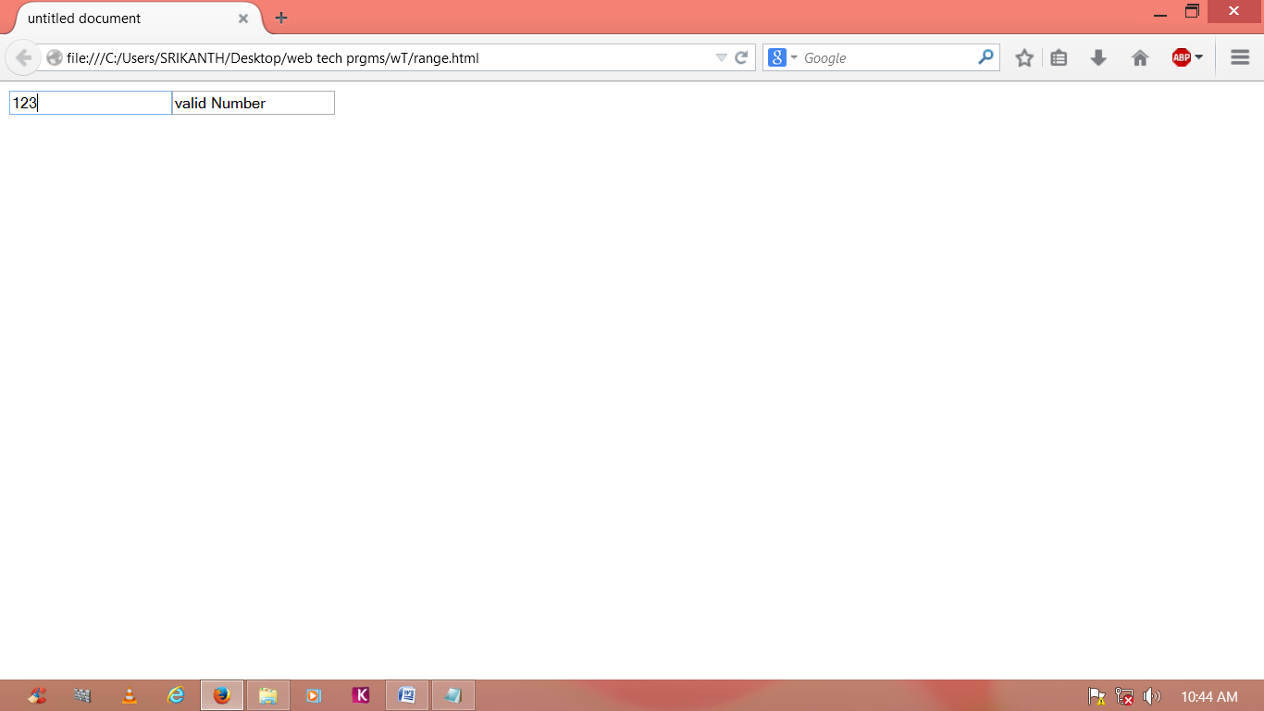
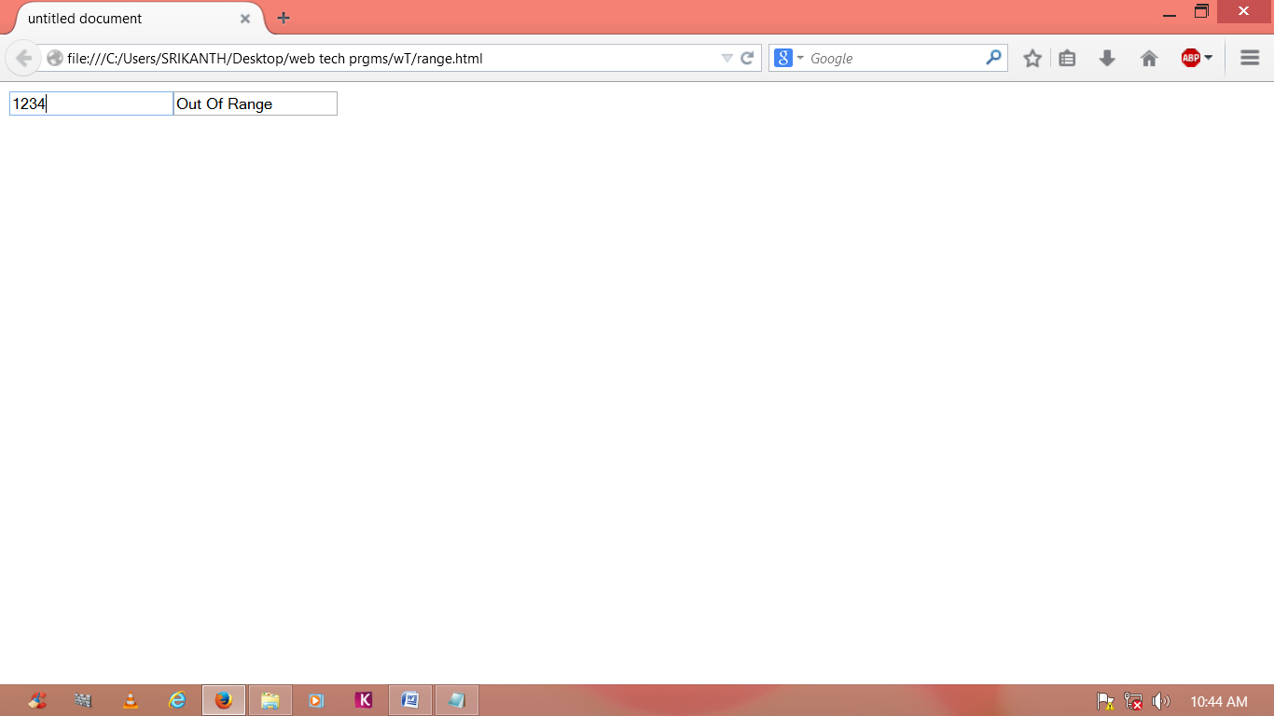
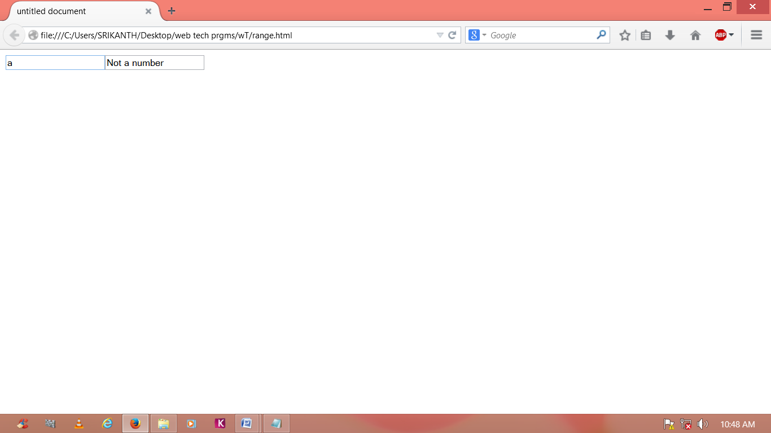
EXECUTED OUTPUT

3.6 LAB VIVA QUESTIONS:
1. What is an example of client side scripting language?
2. What are JavaScript data types?
3. How do we submit the form in JavaScript?
4. What is JavaScript?
5. How to create the text field?
6. What is the purpose of writing document.getElementById ('anumber').value?
EXPERIMENT-4

4.1 OBJECTIVE:
To display the number lines ,words and characters from an HTML page that has on input, which can take multi-line text and a submit button. Once the user clicks the submit button, it should show the number of characters, words and lines in the text entered using an alert message. Words are separated with a white space and lines are separated with new line character.

4.2 PROGRAM LOGIC:
1. Create an HTML File to read the multi-line text using text area field.
2. Once the user clicks the submit button it should show the number of characters ,
words and lines entered in the text area.
3. Include the JavaScript code to count the number of characters, words and lines.

4.3 PROCEDURE:
To execute a PHP program:
1. Open XAMPP control Panel then start Apache Server and Mysql.
2. Open Notepad and Save the php program in htdocs folder of XAMPP.
3. To run the php file open the browser and type the following URL
http://localhost:8086/directory name/filename

4.4 SOURCE CODE:
multiline.html
<!doctype html>
<html>
<head>
<meta charset="utf-8"><title>Untitled Document</title></head>
<body>
<textarea name="Text1" cols="40" rows="5" id="inputbox"></textarea><br/><button onClick="calc()">submit</button>
</body>
</html>
<script> function calc()
{
varinputboxval = document.getElementById("inputbox").value; //varwithoutspace = inputboxval.replace(/ /g,"");
varCharslength = inputboxval.length;
var wordcount = countwords(inputboxval);

var lines = inputboxval.split("\n").length;
alert("Number of charachters"+Charslength+"\nnumber of words : "+wordcount+"\nnumber of lines"+lines)
}
function countwords(str) { return str.split(/\s+/).length;
}
</script>

4.5 INPUT AND OUTPUT:

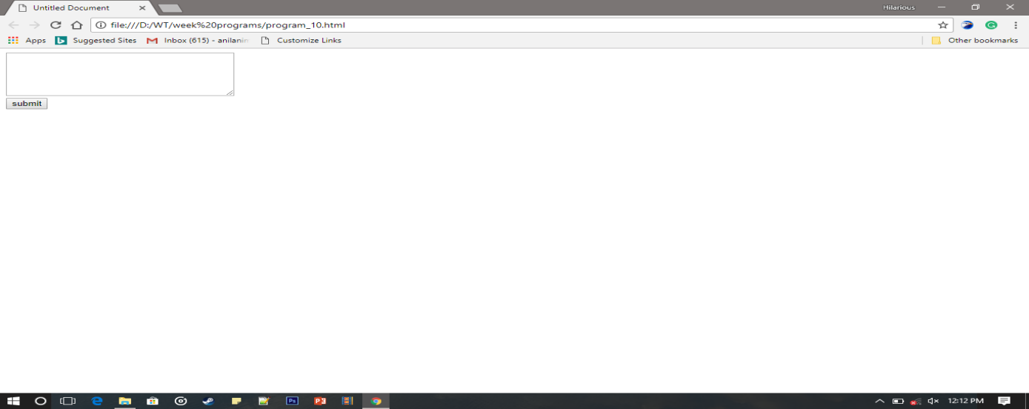
EXECUTED OUTPUT

4.6 LAB VIVA QUESTIONS:
1. How to create the HTML document?
2. How to create the text area in an HTML document?
3. How to create the submit button in an HTML document?
4. What is the purpose of str.split(' ')?
EXPERIMENT-5
5.1 OBJECTIVE:
Write an HTML page that contains a selection box with a list of 5 countries. When
the user selects a country, its capital should be printed next to the list. Add CSS to customize the properties of the font of the capital (color, bold and font size).

5.2 PROGRAM LOGIC:
1. Create an HTML file from which select the country from the selection box.
2. Once the user selects the country it should display the selected country’s capital.
3. Include the JavaScript display the capital for selected country.
4. Create the CSS file which includes the properties like color, bold and font size.
5.3 PROCEDURE:
To execute a PHP program:
1. Open XAMPP control Panel then start Apache Server and Mysql.
2. Open Notepad++ and Save the php program in htdocs folder of XAMPP.
3.To run the php file open the browser and type the following URL
http://localhost:8086/directory name/filename
5.4 SOURCE CODE:
Countries.html
<!doctype html>
<html>
<head>
<meta charset = "uft-8">
<title>countries</title>
</head>
<body>
<select id="countries" onChange="capital()">
<option value="delhi">india</option>
<option value="conberra">australia</option>
<option value="washington-dc">US</option>
<option value="singapore">singapore</option>
<option value="london">UK</option>
</select>
<div>
<ul id="list">
</ul>
</div>
</body>
</html>
<script>
function capital()
{
var country = document.getElementById("countries").text;
var capital=document.getElementById("countries").value;
document.getElementById("list").innerHTML=" ";//first empty UL
varul=document.getElementById("list");//next get element by id
var li=document.createElement("li");//create element to UL
var LI=ul.appendChild(li);//next append li to that element
LI.innerHTML="<p style='color:red;font-size:20px';>"+capital+"</p>";
}
</script>

5.5 INPUT and OUTPUT:

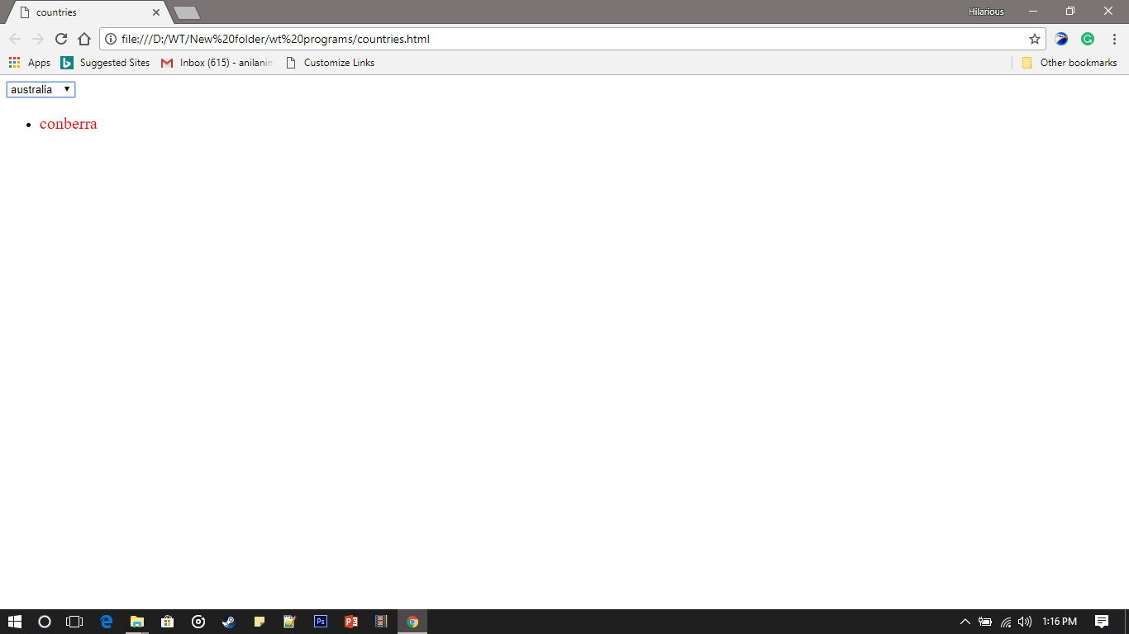

EXECUTED OUTPUT

5.6 LAB VIVA QUESTIONS:
1. How do you insert a comment in html?
2. What are some of the common lists that can be used when designing a page?
3. How do you create links to sections within the same page?
4. Does a hyperlink apply to text only?
5. How do you change the number type in the middle of a list?
6. How do you create a link that will connect to another web page when clicked?

EXPERIMENT 6
6.1 OBJECTIVE:
Create and save an XML document at the server, which contains 10 users information.
Write a program which takes User Id as input and returns the user details by taking the user information from the XML document.
.
6.2 RESOURCES:
JDK Tool Kit, 1GB RAM, Hard Disk 80 GB
6.3 PROGRAM LOGIC:
1. Create a .xml file that has to be parsed.
2. Using DOM parser
i. Get a document builder using document builder factory and parse the xml file to
create a DOM object
ii. Get a list of User elements from the DOM
iii. For each User element id get the name, age and qualification.

6.4 PROCEDURE:
To execute a java program we require setting a class path:
1.C:\set path= C:\Program Files\Java\jdk1.6.0\bin;.;
2.C:\javac Parse.java
3. C:\java Parse
6.5 SOURCE CODE:
XML Program: ReadXML.java
import org.w3c.dom.*;
import javax.xml.parsers.*;
import java.io.*;
import java.util.Scanner;
public class ReadXML{
public static void main(String a[])throws Exception{
DocumentBuilderFactory factory=DocumentBuilderFactory.newInstance();
DocumentBuilder builder=factory.newDocumentBuilder();
//Build Document
Document document=builder.parse(new File("C:\\Users\\SRIKANTH\\Desktop\\web tech prgms\\wT\\employees.xml"));
//Nor
document.getDocumentElement().normalize();
Element root = document.getDocumentElement();
NodeList nList = document.getElementsByTagName("employee");
System.out.println("enter employee id:");
Scanner s=new Scanner(System.in);
String id=s.next();
for(int temp =0;temp <nList.getLength();temp++)
{
Node node = nList.item(temp);
if(node.getNodeType()==Node.ELEMENT_NODE)
{
Element eElement = (Element) node;
if(eElement.getAttribute("id").equals(id)){
System.out.println("firstName:"+eElement.getElementsByTagName("firstName").item(0).getTextContent());
System.out.println("lastName:"+eElement.getElementsByTagName("lastName").item(0).getTextContent());
System.out.println("location:"+eElement.getElementsByTagName("location").item(0).getTextContent());
}
}
}
}
}
Employee.xml
<employees>
<employee id="111">
<firstName>mamatha</firstName>
<lastName>sri</lastName>
<location>hyd</location>
</employee>
<employee id="222">
<firstName>srikanth</firstName>
<lastName>b</lastName>
<location>warangal</location>
</employee>
<employee id="333">
<firstName>sahasra</firstName>
<lastName>s</lastName>
<location>karimnagar</location>
</employee>
<employee id="444">
<firstName>sriman</firstName>
<lastName>sai</lastName>
<location>delhi</location>
</employee>
<employee id="555">
<firstName>suhani</firstName>
<lastName>ayur</lastName>
<location>banglore</location>
</employee>
<employee id="666">
<firstName>sanvi</firstName>
<lastName>more</lastName>
<location>chennai</location>
</employee>
<employee id="777">
<firstName>manish</firstName>
<lastName>k</lastName>
<location>vizag</location>
</employee>
<employee id="888">
<firstName>roshan</firstName>
<lastName>t</lastName>
<location>kerala</location>
</employee>
<employee id="999">
<firstName>pranavi</firstName>
<lastName>g</lastName>
<location>hyd</location>
</employee>
<employee id="1000">
<firstName>pravasthi</firstName>
<lastName>n</lastName>
<location>madura</location>
</employee>
</employees>
6.6 INPUT AND OUTPUT:

Enter Employee id : 444
First Name : sriman
Last Name : sai
Location : delhi
EXECUTED OUTPUT

6.7 LAB VIVA QUESTIONS:
1. What is the purpose of java.io.* package?
2. How to handle the exceptions in java?
3. How to catch exceptions using java language?
4. How to read the XML file using java language?
5. How many types of parsers we have in XML?

EXPERIMENT 7

7.1 OBJECTIVE:
“Implement the following web applications using Servlets”.
A user validation web application, where the user submits the login name and password to the server. The name and password are checked against the data already available in Database and if the data matches, a successful login page is returned. Otherwise a failure message is shown to the user.
7.2 PROGRAM LOGIC:
1. Create the user database and table along with the user name and password as the
attributes.
2. Create an HTML File to retrieve user name and password.
3. Create PHP file to retrieve the data from the database and HTML File.
4. Authenticate the user name and password if it is the valid user the display as
successful login otherwise display failure message.
7.3 PROCEDURE:
To execute a PHP program:
1. Open XAMPP control Panel then start Apache Server and Mysql.
2. Open Notepad and Save the html program in htdocs folder of XAMPP.
3. To run the html file open the browser and type the following URL
localhost:8086/directory name/filename
7.4 SOURCE CODE:
Login.html
<html>
<body>
<form name="login" method="post" action="home.jsp">
<table width="370"border="1"align="center" style="background:silver;">
<tr height=25>
<thcolspan="4"align="center">User Login&nbsp;
</th>
</tr>
<td>User Name</td>
<td><input type="text"name="uname"></td>
</tr>
<tr>
<td>Password</td>
<td><input type="password"name="pwd"></td>
</tr>
<tr align="center"colspan="2">
<input type="submit"name="ok"value="Submit">
</tr>
</table>
</form>
</body>
</html>
StudentLoginServlet.java
import java.io.IOException;
import java.io.PrintWrite;
import java.sql.Connection;
import java.sql.DriverManager;
import java.sql.ResultSet;
import java.sql.SQLException;
import java.sql.Statement;
import javax.servlet.*;
import javax.servlet.http.HttpServlet;
import javax.servlet.http.HttpServletRequest;
import javax.servlet.http.HttpServletResponse;
public class StudentLoginServlet extends HttpServlet
{
private Connection con=null;
public void init() throws ServletException
{
try
{
DriverManager.registerDriver(new com.mysql.jdbc.Driver());
con=DriverManager.getConnection(“jdbc:mysql://localhost:3306/mrits”,”mamatha”);
System.out.println(“not able to database connection”);
e.printStackTrace();
}
}
public void service(HttpServletRequest req,HttpServletResponse resp)throws ServletException,IOException
{
resp.setConnectionType(“text/html”);
Statement statement=null;
ResultSet resultSet=null;
String uname=req.getParameter(“uname”);
String pwd=req.getParameter(“pwd”);
try
{
PrintWriter out=resp.getWriter();
Statement=con.createStatement();
ResultSet rs=statement.executeQuery(“select *from login where uname=”+uname+””and pwd=”+pwd+””);
if (rs.next())
{
RequestDispatcher rd=req.getRequestDispatcher(“home.html”);
rd .forward(req,resp);
}
else
{
RequestDispatcher rd=req.getRequestDispatcher(“Login.html”);
rd.include(req,resp);
out.println(“<h3 align=’center’style=\”color:red;\”>wrong credentials</h3>”);
}
}
Catch(SqlException e )
{
e.printStackTrace();
System.out.println(“not able to get the connection”);
}
finally {
try
{
//con.close();
Sytem.out.println(“connection closed”);
}
catch (Exception e)
{ }
}
}
}
home.html
<h2>welcome to home page-You are successfully logged in</h2><br/>
<a href=”login.html”>Back</a>
web.xml
<web-app>
<welcome-file-list>
<welcome-file>index.html</welcome-file>
</welcome-file-list>
<servlet>
<servlet-name>sls</servlet-name>
<servlet-class>pres.Student.orginServlet</servlet-class>
</servlet>
<servlet-mapping>
<servlet-name>sls</servlet-name>
<url-pattern>/sls</url-pattern>
</servlet-mapping>
</web-app>
7.5 INPUT AND OUTPUT:

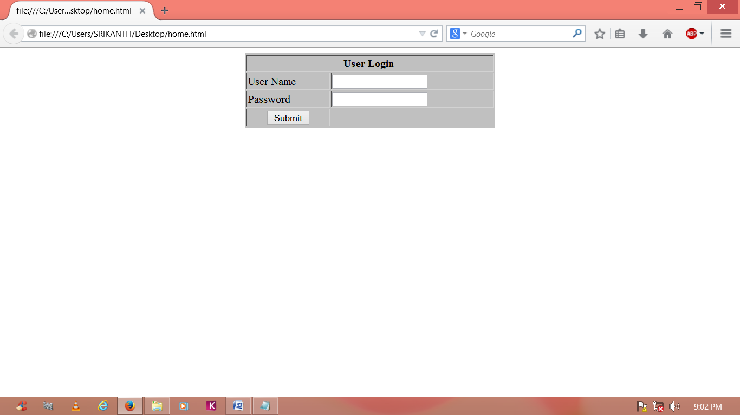
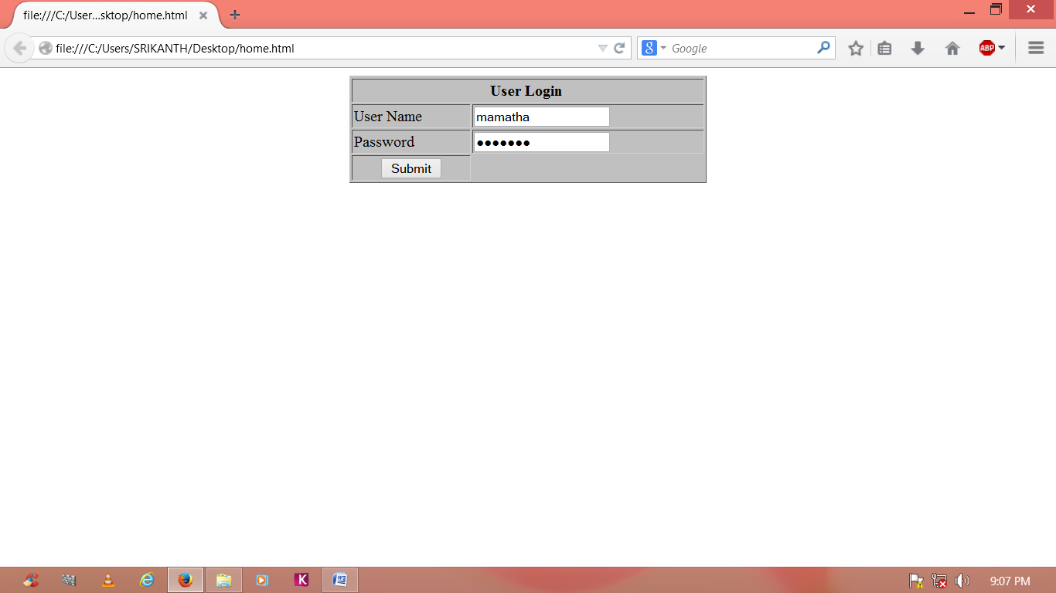
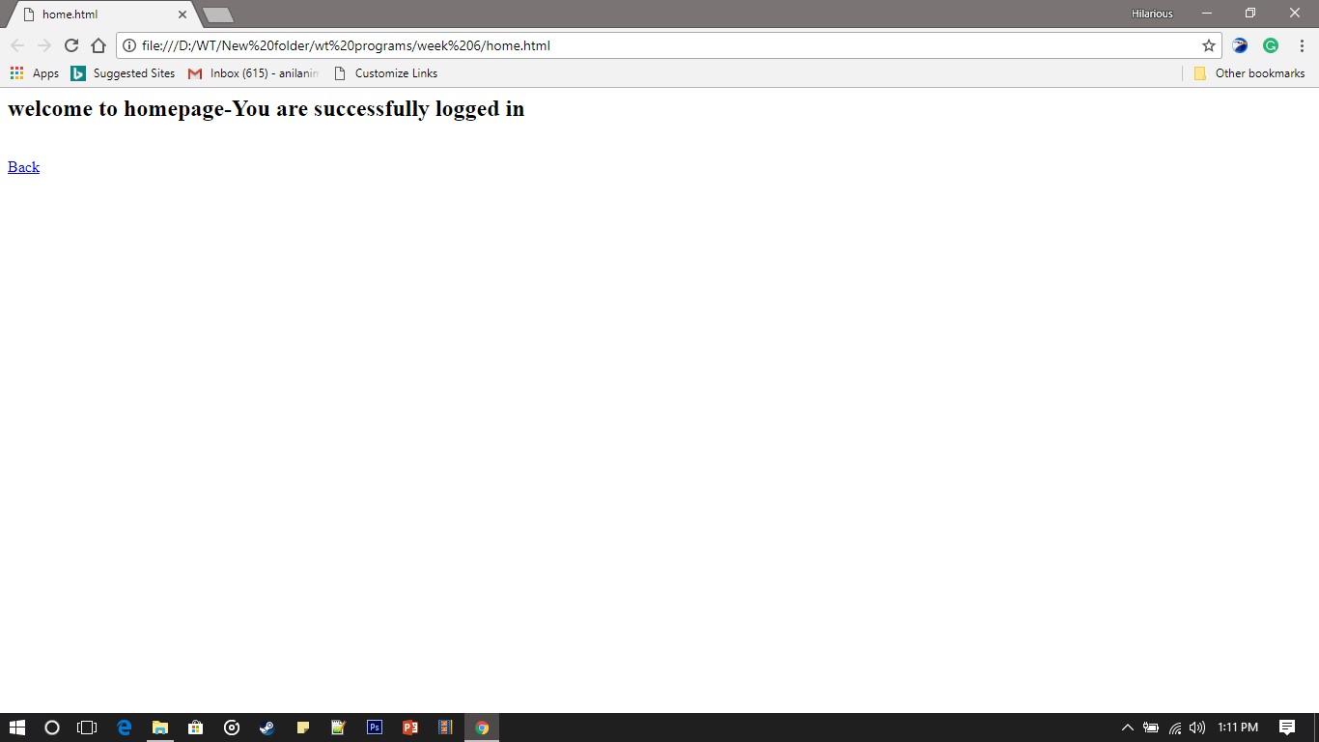

EXECUTED OUTPUT

7.6 PRE LAB VIVA QUESTIONS:
1. Whether root element is required for XML? If so, how many root elements are
required?
2. What are the disadvantages of xml?
3. Is there a way to describe XML data?
4. What is well formed XML document?
5. Why do we use multipart/form-data in html form?
6. What function do we use to find length of string, and length of array?

EXPERIMENT 8
8.1 OBJECTIVE:
Modify the above program to use an XML file instead of database.
8.2 PROGRAM LOGIC:
1. Create the user database and table along with the user name and password as the
attributes.
2. Create an HTML File to retrieve user name and password.
3. Create PHP file to retrieve the data from the database and HTML File.
4. Authenticate the user name and password if it is the valid user the display as successful
login otherwise display failure message.
8.3 PROCEDURE:
To execute a PHP program:
1. Open XAMPP control Panel then start Apache Server and Mysql.
2. Open Notepad and Save the html program in htdocs folder of XAMPP.
3. To run the html file open the browser and type the following URL
http://localhost:8086/directory name/filename

8.4 Source code
login.html
<html><body>
<form name="login" method="post" action="sls">
<table width="370"border="1"align="center" style="background:silver;">
<tr height=25>
<th colspan="4"align="center">User Login&nbsp;
</th>
</tr>
<td>User Name</td>
<td><input type="text"name="uname"></td>
</tr>
<tr><br>
<td>Password</td>
<td><input type="password"name="pwd"></td>
</tr><br>
<tr align="center"colspan="2">
<input type="submit"name="ok"value="Submit">
</tr>
</table>
</form></body></html>
StudentLoginServlet.java
import java.io.IOException;
import java.io.PrintWrite;
import javax.servlet.*;
import javax.servlet.http.HttpServlet;
import javax.servlet.http.HttpServletRequest;
import javax.servlet.http.HttpServletResponse;
public class StudentLoginServlet extends HttpServlet
{
public void service(HttpServletRequest req,HttpServletResponse resp)throws ServletException,IOException{
resp.setConnectionType(“text/html”);
PrintWrite out=resp.getWriter();
ServletConfig config=getServletConfig();
String un=req.getParameter(“uname”);
String pw=req.getParameter(“pwd”);
String uname=config.getInitParameter(“uname”);
String pwd=congig.getInitParameter(“pwd”);
if(uname.equals(uname)&&pw.equals(pwd))
{
RequestDispatcher rd=req.getRequestDispatcher(“home.html”);
rd.forward(req,resp);
}
else
{
RequestDispatcher rd1=req.getRequestDispatcher(“login.html”);
rd1.include(req,resp);
out.println(“<h3 align=’center’Style=\”color:red;\”>wrong credentials</h3>”);
}
}
}
home.html
<h2>welcome to home page-You are successfully logged in</h2><br/>
<a href=”login.html”>Back</a>
Web.xml
<web-app>
<servlet>
<servlet-name>sls</servlet-name>
<servlet-class>pres.StudentLoginServlet</servlet-class>
<init-param>
<param-name>uname</param-name>
<param-value>mamatha</param-value>
</init-param>
</servlet>
<servlet-mapping>
<servlet-name>sls</servlet-name>
<url-pattern>/sls</url-pattern>
</servlet-mapping>
</web-app>
8.5 INPUT AND OUTPUT:

EXECUTED OUTPUT

8.6 VIVA QUESTIONS:
1. Whether root element is required for XML? If so, how many root elements are
required?
2. What are the disadvantages of xml?
3. Is there a way to describe XML data?
4. What is well formed XML document?
5. Why do we use multipart/form-data in html form?
6. What function do we use to find length of string, and length of array?

EXPERIMENT 9
9.1 OBJECTIVE:
Modify the above program using AJAX to show the result on the same page below
the submit button.

9.2 PROGRAM LOGIC:
1. Create an HTML File to read the Username and Password Using Text field.
2. Once the user clicks the submit button validate username and password from Xml
file.
3.It displays “welcome to home page”.

9.3 PROCEDURE:
To execute a PHP program:
1.Open XAMPP control Panel then start Apache Server and Mysql.
2.Open Notepad and Save the html program in htdocs folder of XAMPP.
3.To run the html file open the browser and type the following URL
localhost:8086/directory name/filename

9.4 SOURCE CODE:
index.html
<!doctype html>
<html>
<head>
<meta charser=”utf-8”>
<title>Login</title>
</head>
<body>
<form method=”GET” action=”Login.html”>
User Name:<input type=”text”name=”uname” value=”” ><br>
Password:&nbsp<input type="password"name="pwd"><br>
<button type=”submit”>Submit</button>
</form>
<div id=”result”></div>
<script>
var xhttp = new XMLHttpRequest();
var loginForm = document.getElementById(‘loginForm’);
loginForm.addEventListener(“submit”,submit,false);
function submit(e)
{
e.preventDefault();
var username = document.getElementById(‘name’).value;
varuserpwd = document.getElementById(‘pwd’).value;
var result = document.getElementById(“result”);
xhttp.onreadystatechange = function()
{
if(xhttp.readyState == 4 &&xhttp.status == 200)
{
var xmlDoc = xhttp.responseXML;
var name = xmlDoc.getElementsByTagName(“name”)[0].childNodes[0].nodeValue;
var pwd=xmlDoc.getElementsByTagName(“pwd”)[0].childNodes[0].nodeValue;
console.log(name+pwd);
if(name==username &&pwd == userpwd)
{
result.innerHTML = ‘<h1>Successfully logged in</h1>’;
}
else
{
result.innerHTML=’<h1>Wrong Details</h1>’;
}
loginForm.reset();
}
};
xhttp.open(“GET”, “user.xml”, true);
xhttp.send();
}
</script>
</body>
</html>
Login.html
<!doctype html>
<html>
<head>
<meta charset=”utf-8”>
<title>Login</title>
</head>
<body>
<h1>Successfully logged in</h1>
</body>
</html>
users.xml
<?xml version=”1.0” encoding=”utf-8”?>
<users>
<name>mamatha</name>
<pwd>admin</pwd>
</users>
9.5 INPUT AND OUTPUT:

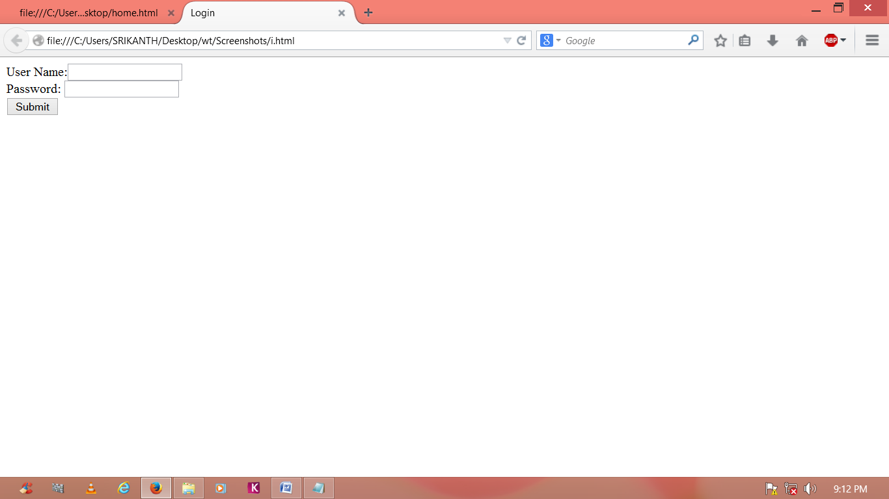
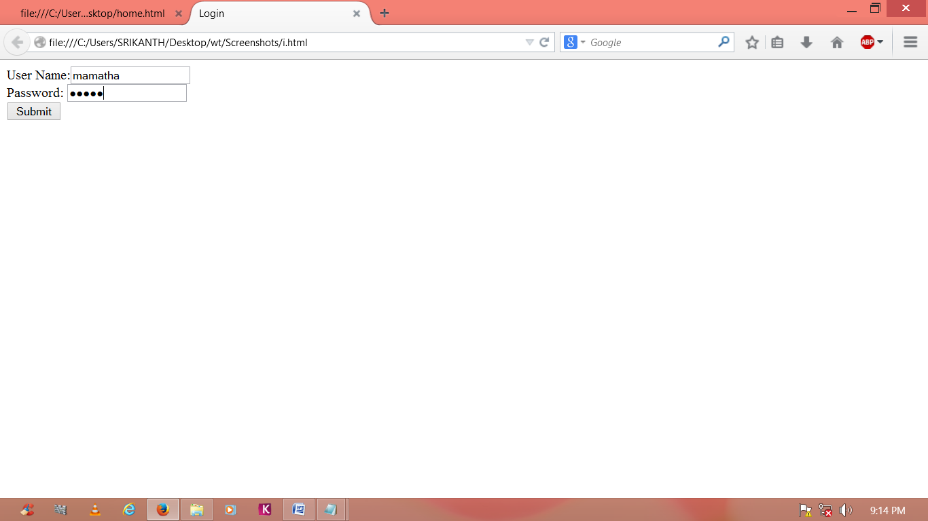

EXECUTED OUTPUT

9.6 VIVA QUESTIONS:
1. Define AJAX?
2. What is the Use of XMLHttpRequest() ?
3. Explain xhttp.onreadystatechange method?

EXPERIMENT 10
10.1 OBJECTIVE:
A simple calculator application that takes two numbers and an operator (+,-,*,/,%) from
an HTML page and returns the result page with the operation performed on the operands.
10.2 PROGRAM LOGIC:
1. Create an HTML File to read the numbers using buttons.
2. select any two numbers and operator, it displays the result in result box.

10.3 PROCEDURE:
To execute a PHP program:
1. Open XAMPP control Panel then start Apache Server and Mysql.
2. Open Notepad and Save the html program in htdocs folder of XAMPP.
3.To run the html file open the browser and type the following URL
localhost:8086/directory name/filename.

10.4 SOURCE CODE:
cal.html
<html>
<head>
<title>Html Calculater</title>
</head>
<body bgcolor=”#000000 “text=”gold”>
<form name=”calculator”>
<input type=”button”value=”1” onClick=”document.calculator.ans.value+=’1’”>
<input type=”button”value=”2” onClick=”document.calculator.ans.value+=’2’”>
<input type=”button”value=”3” onClick=”document.calculator.ans.value+=’3’”>
<input type=”button”value=”+” onClick=”document.calculator.ans.value+=’+’”>
<br>
<input type=”button”value=”4” onClick=”document.calculator.ans.value+=’4’”>
<input type=”button”value=”5” onClick=”document.calculator.ans.value+=’5’”>
<input type=”button”value=”6” onClick=”document.calculator.ans.value+=’6’”>
<input type=”button”value=”-” onClick=”document.calculator.ans.value+=’-’”>
<br>
<input type=”button”value=”7” onClick=”document.calculator.ans.value+=’7’”>
<input type=”button”value=”8” onClick=”document.calculator.ans.value+=’8’”>
<input type=”button”value=”9” onClick=”document.calculator.ans.value+=’9’”>
<input type=”button”value=”*” onClick=”document.calculator.ans.value+=’*’”>
<br>
<input type=”button”value=”/” onClick=”document.calculator.ans.value+=’/’”>
<input type=”button”value=”0” onClick=”document.calculator.ans.value+=’0’”>
<input type=”button”value=”%” onClick=”document.calculator.ans.value+=’%’”>
<input type=”button”value=”1” onClick=”document.calculator.ans.value=eval(document.calculator.ans.value)”>
<br>
<input type=”reset” value=”Reset”>
Solution is<input type=”textfield” name = “ans” value=””>
</form>
</body>
</html>
10.5 INPUT AND OUTPUT:
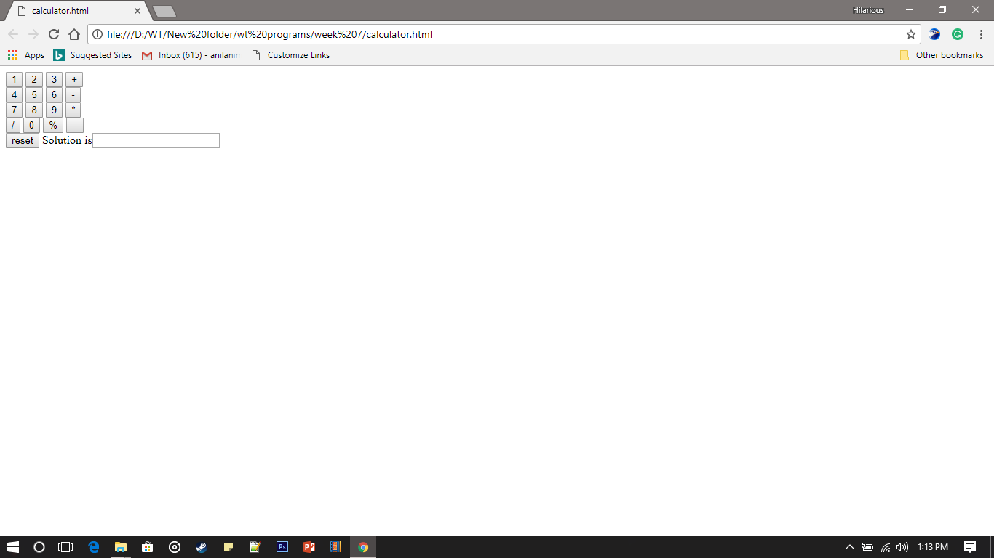
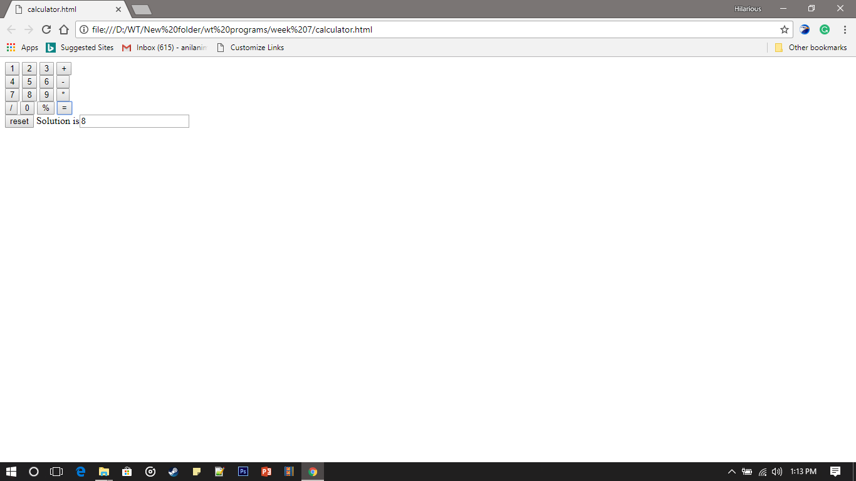

EXECUTED OUTPUT

10.6 VIVA QUESTIONS:
1. Explain about onClick and onSubmit?
2. What is the Use of document.calculator.ans.value()?

EXPERIMENT-11
11.1 OBJECTIVE:
Modify the above program such that it stores each query in a database and checks the database first for the result. If the query is already available in the DB, it returns the value that was previously computed (from DB) or it computes the result and returns it after storing the new query and result in DB.
11.2 PROGRAM LOGIC:
1. Create the user database and table along with the user name and password as the
attributes.
2. Create an HTML File to retrieve user name and password.
3. Create PHP file to retrieve the data from the database and HTML File.
4. If the query is already available in the DB, it returns the value that was previously
computed (from DB) or it computes the result and returns it after storing the new
query and result in DB.

11.3 PROCEDURE:
To execute a PHP program:
1. Open XAMPP control Panel then start Apache Server and Mysql.
2. Open Notepad and Save the html program in htdocs folder of XAMPP.
3. To run the html file open the browser and type the following URL
http://localhost:8086/directory name/filename
11.4 SOURCE CODE:
query.java
import java.sql.*;
import java.util.*;
class query
{
public static void main(String a[])
{
//Creating the connection
String url = "jdbc:oracle:thin:@localhost:1521:xe";
String user = "system";
String pass = "12345";

//Entering the data
Scanner k = new Scanner(System.in);
System.out.println("enter name");
String name = k.next();
System.out.println("enter roll no");
int roll = k.nextInt();
System.out.println("enter class");
String cls = k.next();

//Inserting data using SQL query
String sql = "insert into student1 values('"+name+"',"+roll+",'"+cls+"')";
Connection con=null;
try
{
DriverManager.registerDriver(new oracle.jdbc.OracleDriver());

//Reference to connection interface
con = DriverManager.getConnection(url,user,pass);

Statement st = con.createStatement();
int m = st.executeUpdate(sql);
if (m == 1)
System.out.println("inserted successfully : "+sql);
else
System.out.println("insertion failed");
con.close();
}
catch(Exception ex)
{
System.err.println(ex);
}
}
}

11.5 INPUT AND OUTPUT:
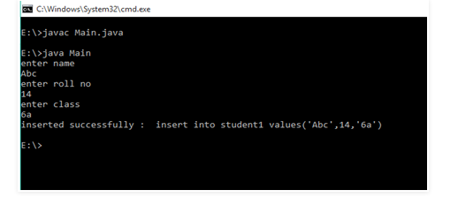
EXECUTED OUTPUT

11.6 VIVA QUESTIONS

- Define Database.
- Define Sql.

EXPERIMENT 12

12.1 OBJECTIVE:
A web application takes a name as input and on submit it shows a hello<name>page where<name> is taken from the request. It shows the start time at the right top corner of the page and provides the logout button. On clicking this button, it should show a logout page with Thank You<name> message with the duration of usage.(Use session to store name and time).
12.2 PROGRAM LOGIC:
1. Create an HTML File to read the user name and password using text field.
2. Once the user clicks the submit button it should show the user name and display the
duration of usage.
12.3 PROCEDURE:
To execute a PHP program:
1. Open XAMPP control Panel then start Apache Server and Mysql.
2. Open Notepad and Save the html program in htdocs folder of XAMPP.
3. To run the html file open the browser and type the following URL
localhost:8086/directory name/filename

12.4 SOURCE CODE:

Login2.html
<html><body>
<form name="login" method="post" action="hello.jsp">
<table width="370"border="1"align="center" style="background:silver;">
<tr height=25>
<th colspan="4"align="center">User Login&nbsp;
</th>
</tr>
<td>User Name</td>
<td><input type="text"name="uname"></td>
</tr>
<tr>
<td>Password</td>
<td><input type="password"name="pwd"></td>
</tr>
<tr align="center"colspan="2">
<input type="submit"name="ok"value="Submit">
</tr>
</table>
</form></body></html>
hello.jsp
<%@ page import = “java.util.Date”%>
<%
String uname = request.getParameter(“uname”);
session.setAttribute(“uname”,uname);
Date d = new Date();
session.setAttribute(“time”,d.getSeconds());
%>
<h2 align = “center”>hello<%=uname %></h2>
<h4 align=”right”><%=d %></h4><br>
<a href =”thanks.jsp” align = “center”>Logout</a>
thanks.jsp
<% @ page import=”java.util.Date” %>
<%
String uname=(String)session.getAttribute(“uname”);
int time=(Integer)session.getAttribute(“time”);
Date d =new Date();
int current = d.getSeconds()-time;
%>
<h2 align = “center”>Thank you<%=uname %></h2><br>
<h2 align =”center”>Your duration is <%=current %>Seconds</h2>
12.5 INPUT AND OUTPUT:

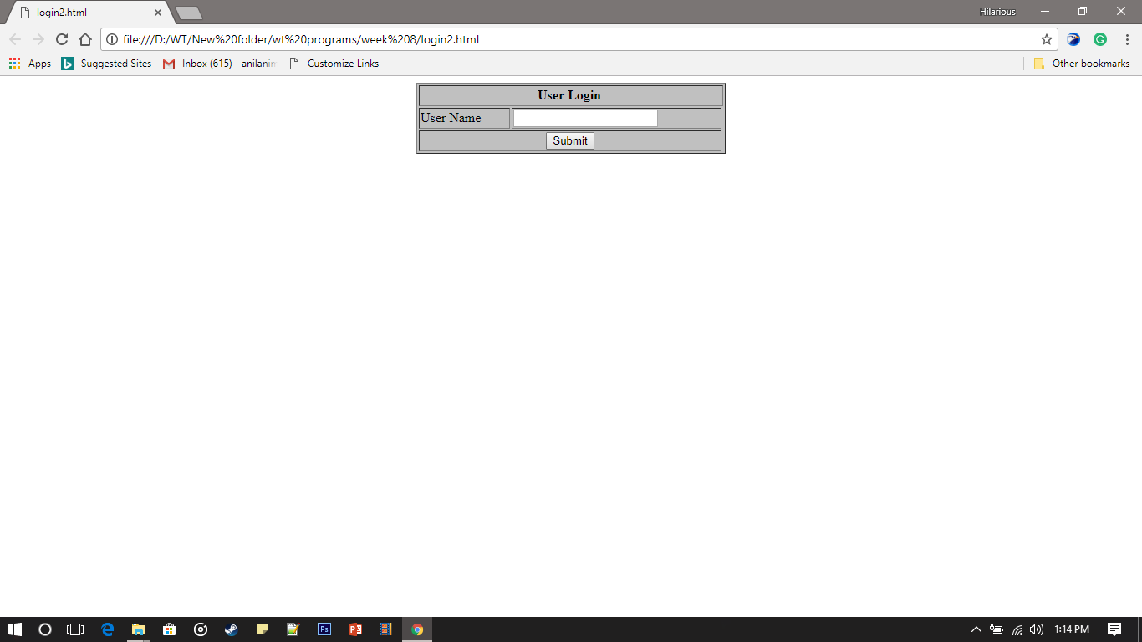

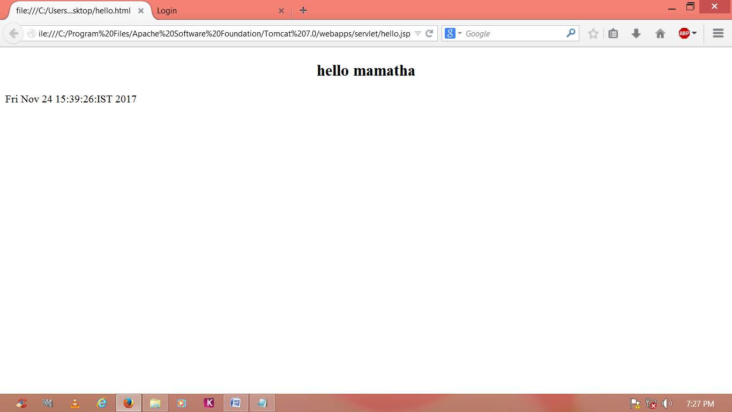

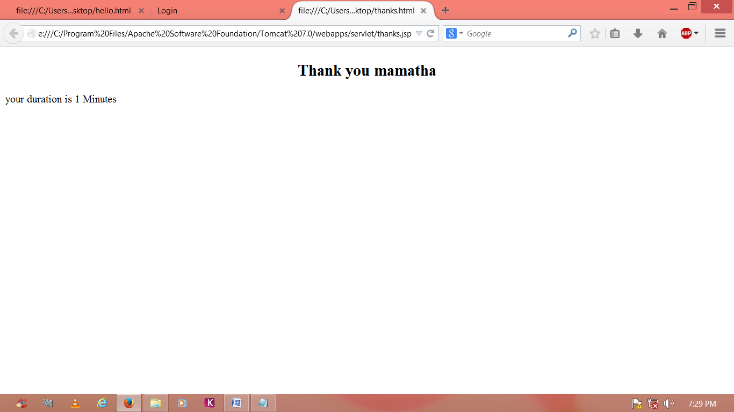

EXECUTED OUTPUT

12.6 VIVA QUESTIONS:
1. Define session?
2. Abbreviation of JSP?
EXPERIMENT 13
13.1 OBJECTIVE:
A web application that takes name and age from an HTML page. If the age is less than
18, it should send a page with “Hello <name>, you are not authorized to visit this site”
message, where <name> should be replaced with the entered name. Otherwise it should
send “Welcome <name> to this site” message.
13.2 PROGRAM LOGIC:
1. Create an HTML File to read the User name and Age using text area field.
2. Once the user clicks the submit button the jsp file validate the user age.
3. If the user age is less than 18,it display the message “Hello Your are not authorised,”
else display “ Welcome to this site”.
13.3 PROCEDURE:
To execute a PHP program:
1.Open XAMPP control Panel then start Apache Server and Mysql.
2.Open Notepad and Save the html program in htdocs folder of XAMPP.
3.To run the html file open the browser and type the following URL
localhost:80860/directory name/filename

13.4 SOURCE CODE:

Login7.html
<html>
<body>
<form name="login" method="post" action="home.jsp">
<table width="370"border="1"align="center" style="background:silver;">
<tr height=25>
<th colspan="4"align="center">User Login&nbsp;
</th>
</tr>
<td>User Name</td>
<td><input type="text"name="uname"></td>
</tr>
<tr>
<td>Age</td>
<td><input type="text"name="uname"></td>
</tr>
<tr align="center"colspan="3">
<td><input type="submit"name="ok"value="Submit"></td>
</tr>
</table>
</form></body></html>
hello7.jsp
<%
String uname = request.getParameter(“uname”);
session.setAttribute(“uname”,uname);
int age = Integer.parseInt(request.setParameter(“age”));
if(age<18)
{
out.println(“<h4 align = ‘center’>Hello\t” +uname+”,\t you are not authorized to visit this site</h4>”);
RequestDispatcher rd = request.getRequestDispatcher(“login7.jsp”);
rd.include(request,response);
}
else
{
out.println(“Hello\t”+uname+”,\t Welcome to this site”);
}
% >

13.5 INPUT AND OUTPUT:
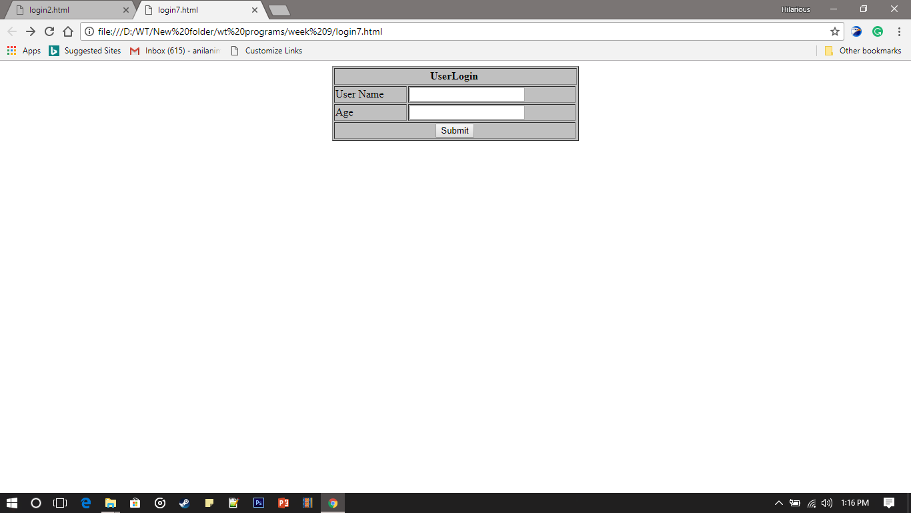

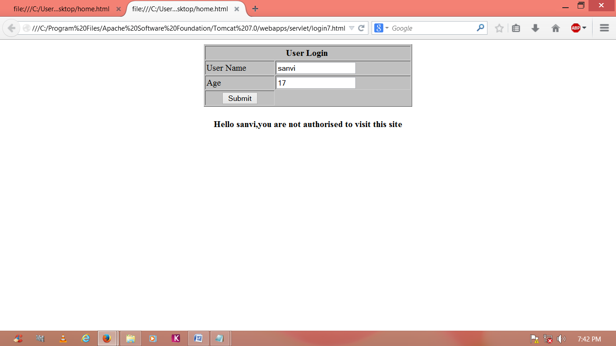
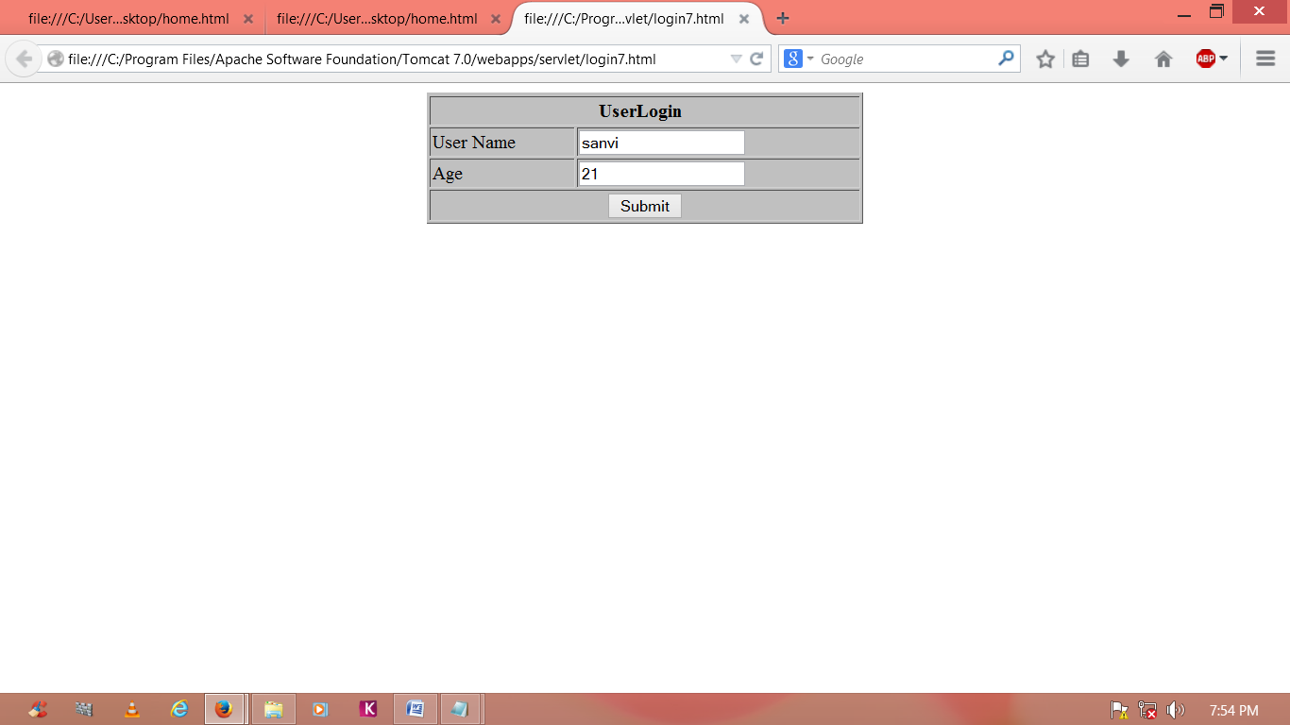
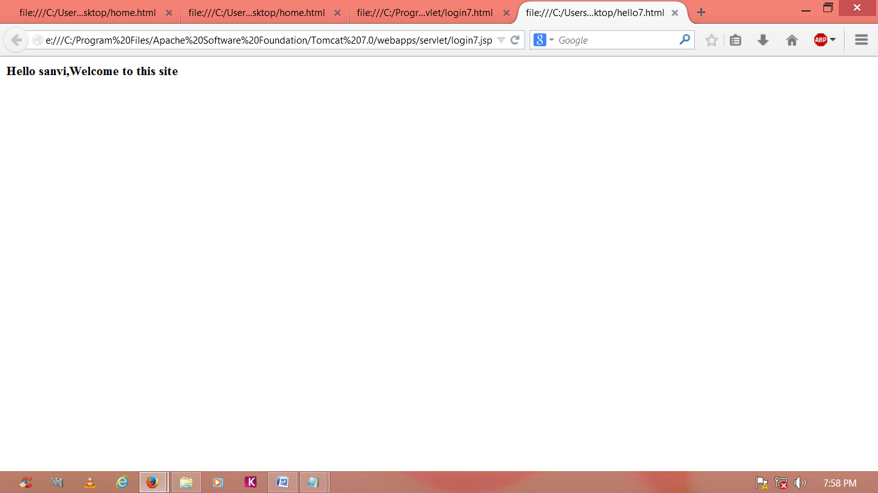

EXECUTED OUTPUT

13.6 VIVA QUESTIONS:
1.What is the use of RequestDispatcher?
2. What is the use of Integer.parseInt() ?

EXPERIMENT 14
14.1 OBJECTIVES:
A web application for implementation:
The user is first served a login page which takes user’s name and password. After
Submitting the details the server checks these values against the data from a database and takes the following decisions.
- If name and password matches serves a welcome page with user’s full name.
- If name and password doesn’t match, then serves “password mismatch” page.
- If name is not found in the database, serves a registration page, where user’s full name is asked and on submitting the full name, it stores, the login name, password and full name in the database (hint: use session for storing data, submitted login name and password).
14.2 SOURCE CODE:
login8.html
<html>
<body>
<form name="login" method="post" action="sls">
<table width="370" border="1" align="center" style="background:silver;">
<tr height=25 bgcolor="">

<th colspan="4" align="center">User Login&nbsp;
</th>
</tr>
<tr>
<td>User Name</td>
<td><input type="text" name="uname"></td>
</tr>
<tr>
<td>Password</td>
<td><input type="password"name="pwd"></td>
</tr>
<tr align="center">
<td align="center"colspan="2">
<input type="submit"name="ok" value="Submit">
</tr>
</table>
</form></body></html>
StudentLoginServlet.java
package pres;
import java.io.IOException;
import java.io.PrintWrite;
import java.sql.Connection;
import java.sql.DriverManager;
import java.sql.ResultSet;
import java.sql.SQLException;
import java.sql.Statement;
import javax.servlet.*;
import javax.servlet.http.HttpServlet;
import javax.servlet.http.HttpServletRequest;
import javax.servlet.http.HttpServletResponse;
import javax.servlet.http.HttpSession;
public class StudentLoginServlet extends HttpServlet
{
private Connection con = null;
public void init() throws ServletException
{
try
{
DriverManager.registerDriver(new com.mysql.jdbc.Driver());
con= DriverManager.getConnection(“jdbc:mysql://localhost:8080/mrits”,”root”,”mamatha”);
}
catch(Exception e)
{
e.printStackTrace();
}
}
public void service(HttpServletRequestreq,HttpServletResponseresp)throws ServletException,IOException
{
resp.setContentType(“text/html”);
Statement stmt = null;
ResultSet rs =null;
HttpSession ses = req.getSession();
string uname =req.getSession();
string uname =req.getParameter(“uname”);
string pwd = req.getParameter(“pwd”);
try
{
printwrite out =resp.getWriter();
stmt = con.createStatement();
ResultSet rs=stmt.executeQuery(“select uname,pwd,fullname from login where uname= ‘”+uname+”’ ”);
if(rs.next())
{
if(pwd.equals(rs.getString(“pwd”)))
{
ses.setAttribute(“fullname”,rs.getString(“fullname”));
RequestDispatcher rd = req.getRequestDispatcher(“home8.jsp”);
rd.forward(req,resp);
}
else
{
RequestDispatcher rd = req.getRequestDispatcher(“login8.jsp”);
rd.include(req,resp);
out.println(“<h3 align =’center’ style =\”color : red;\”>Password Mismatch</h3>”);
}
}
else
{
out.println(“<h3 align =’center’ style=\”color : red;\”>Please register ur details</h3>”);
RequestDispatcher rd = req.getRequestDispatcher(“registration.jsp”);
rd.include(req,resp);
}
}
catch(SQLException e)
e.printStackTrace();
System.out.println(“not able to get the connection”);
}
finally
{
try
{
//con.close();
system.out.println(“connection closed”);
}
catch(Exception e)
{ }
}
}}

home8.jsp
<h2>Hi<% = (String)session.getAttribute(“fullname”)%>!</h2><br/>
<h2>welcome to home page-You are successfully logged in</h2><br/>
<a href =”login8.jsp”>Back</a>

registration.jsp
<HTML>
<body>
<form name="login" method="post" action="hello7.jsp">
<table width="370" border="1" align="center"style="background:silver;">
<tr height=25 bgcolor=" ">
<th colspan="4" align="center">UserLogin &nbsp;
</th>
</tr>
<tr>
<td>User Name</td>
<td><input type="text" name="uname"></td>
</tr>
<tr>
<td>Password</td>
<td><input type="password"name="pwd"></td>
</tr>
<tr>
<td>Full Name</td>
<td><input type="text" name="fname">
</td>
</tr>
<tr align="center">
<td align="center" colspan="2">
<input type="submit"name="ok" value="Submit">
</tr>
</table>
</form>
</body></html>
StudentRegisterServlet.java
import java.io.IOException;
import java.io.PrintWrite;
import java.sql.Connection;
import java.sql.DriverManager;
import java.sql.ResultSet;
import java.sql.SQLException;
import java.sql.Statement;
import javax.servlet.*;
import javax.servlet.http.HttpServlet;
import javax.servlet.http.HttpServletRequest;
import javax.servlet.http.HttpServletResponse;
import java.sql.PreparedStatement;
import javax.servlet.http.HttpSession;
public class StudentRegisterServlet extends HttpServlet
{
private Connection con = null;
public void init() throws ServletException
{
try
{
DriverManager.registerDriver(new com.mysql.jdbc.Driver());
con= DriverManager.getConnection(“jdbc:mysql://localhost:8080/mrits”,”root”,”mamatha”);
}
catch(Exception e)
{
e.printStackTrace();
}
}
public void service(HttpServletRequestreq,HttpServletResponseresp)throws ServletException,IOException
{
resp.setContentType(“text/html”);
PreparedStatement ps =null;
ResultSet rs =null;
HttpSession ses = req.getSession();
string uname =req.getSession();
string uname =req.getParameter(“uname”);
string pwd = req.getParameter(“pwd”);
try
{
Printwriter out =resp.getWriter();
ps.con.prepareStatement(“insert into login(uname,pwd,fullname)values(?,?,?)”);
ps.setString(1,uname);
ps.setString(2,pwd);
ps.setString(3,fullname);
ps.executeUpdate();
out.println(“<h3 align=’center’ style=\”color:green;\”>Your details have been registered successfully – please login</h3>”);
RequestDispatcher rd=req.getRequestDispatcher(“login8.jsp”);
rd.include(req,res);
}
catch(SQLException e)
{
e.printStackTrace();
System.out.println(“not able to get the connection”);
}
finally
{
try
{
con.close();
System.out.println(“connection closed”);
}
catch(Exception e)
{ }
}
}
}
web.xml
<web-app>
<servlet>
<servlet-name>sls</servlet-name>
<servlet-class>pres.StudentLoginServlet</servlet-class>
</servlet>
servlet>
<servlet-name>srs</servlet-name>
<servlet-class>pres.StudentRegisterServlet</servlet-class>
</servlet>
<servlet-mapping>
<servlet-name>sls</servlet-name>
<url-pattern>//sls</url-pattern>
</servlet-mapping>
<servlet-mapping>
<servlet-name>srs</servlet-name>
<url-pattern>//srs</url-pattern>
</servlet-mapping>
</web-app>

14.3 INPUT AND OUTPUT:
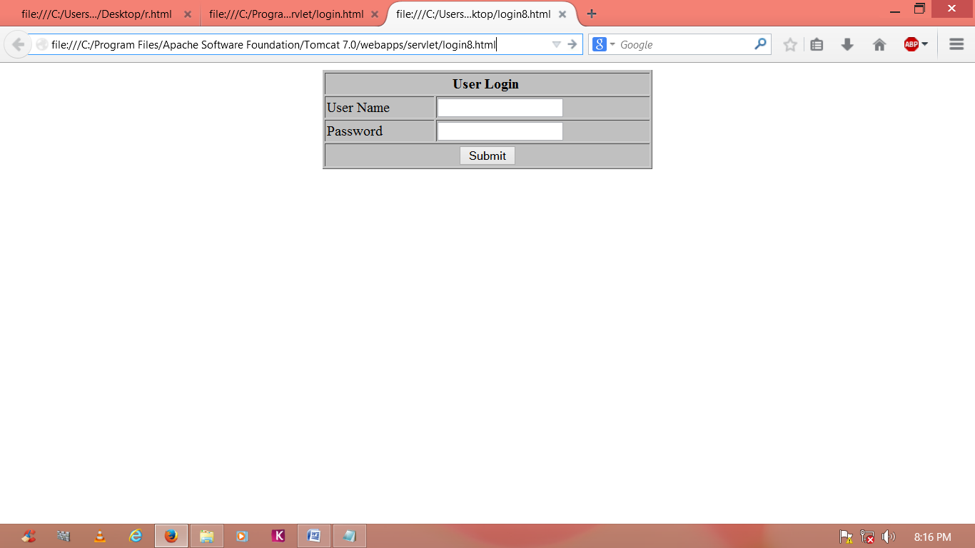
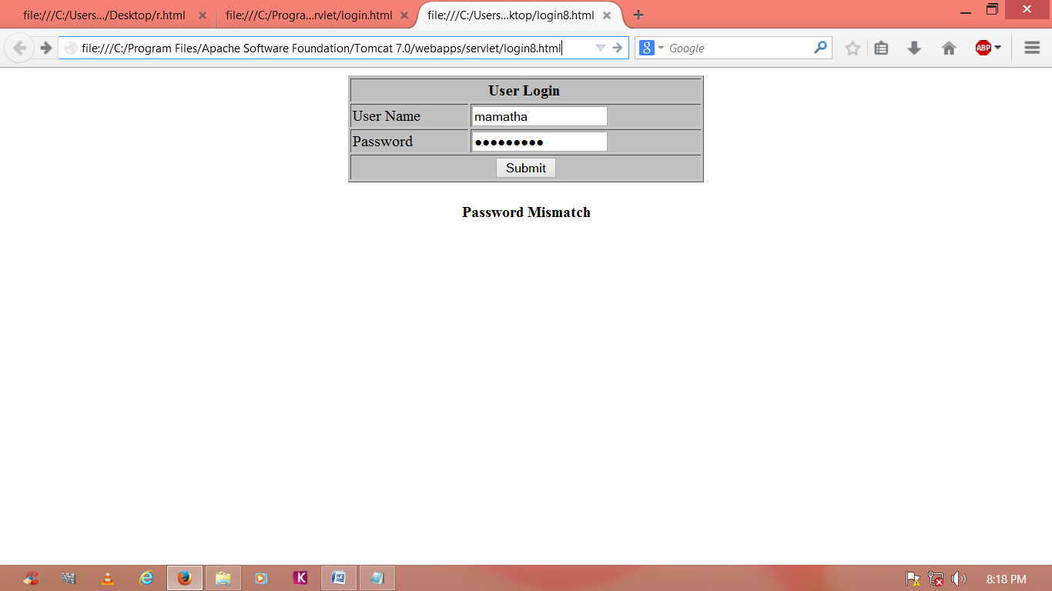
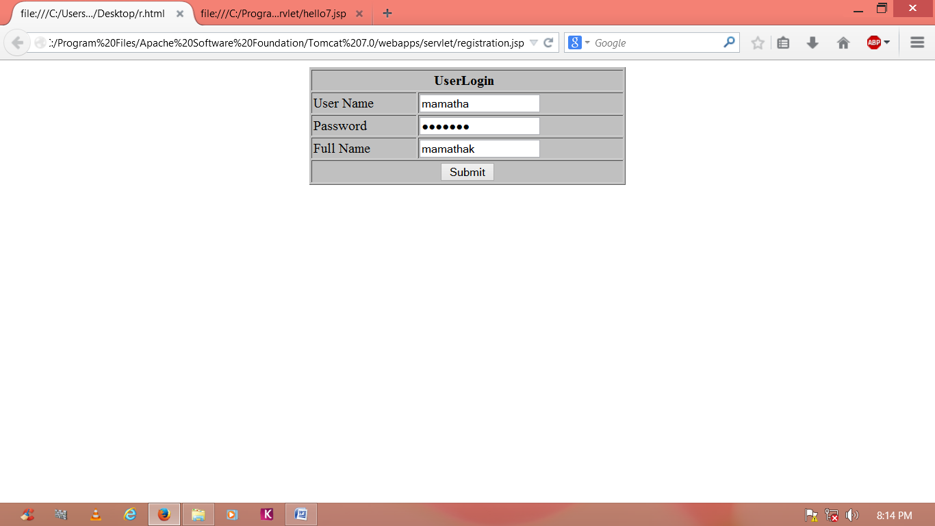
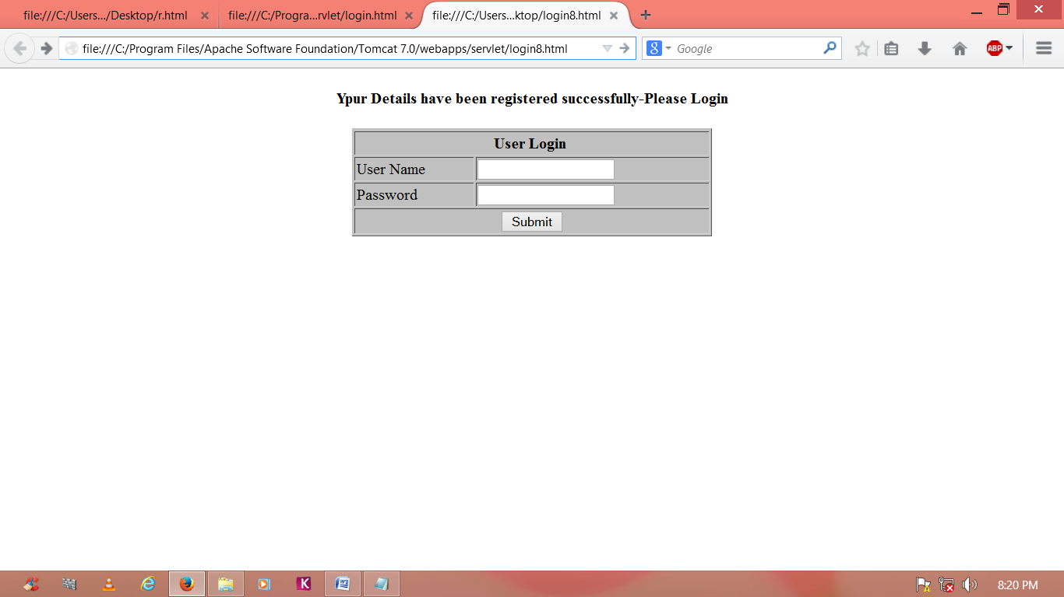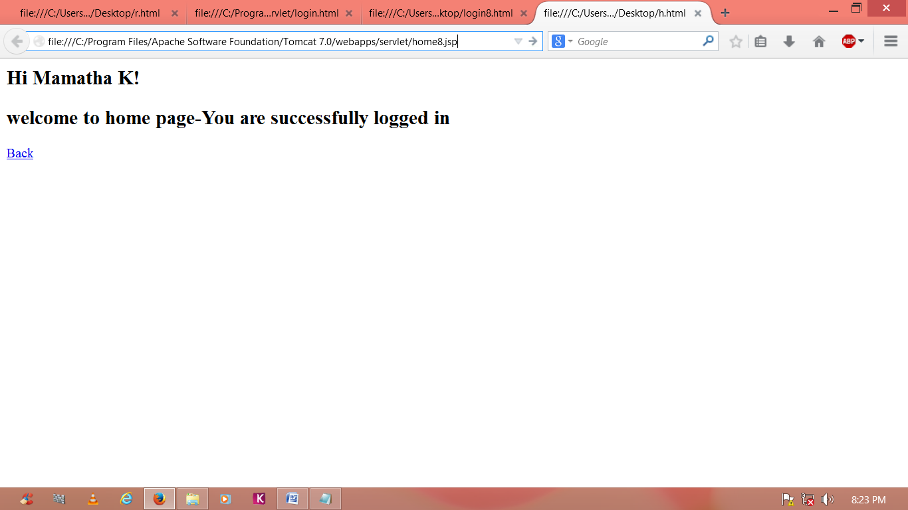

EXECUTED OUTPUT

14.4 VIVA QUESTIONS:
1. Define JDBC?
2. What is the Use of Printwriter?
3. What is the Use of ResultSet

EXPERIMENT 15

15.1 OBJECTIVE:
A web application that lists all cookies stored in the browser on clicking “List Cookies” button. Add cookies if necessary.

15.2 SOURCE CODE
listcookie.jsp
<%
//create cookies for first and last names.
Cookie firstName = new Cookies(“first_name”,”mamatha”);
Cookies lastName = new Cookies(“last_name”,”sri”);
//set expiry date after 24 Hrs for both the cookies.
firstName.setMaxAge(60*60*24);
lastName.setMaxAge(60*60*24);
//Add both the cookies in the response header.
response.addCookie(firstName);
response.addCookies(lastName);
//read cookies
Cookie cookie = null;
Cookie[] cookies = null;
//get an array of Cookies associated with this domain
cookies = request.getCookies();
if(cookies !=null)
{
out.println(“<h2>Found Cookies Name and Value</h2>”);
for(inti=0;i<=cookies.length;i++)
{
cookies = cookies[i];
out.print(“Name:”+cookie.getName()+”,”);
out.print(“value:”+cookie.getValue()+”<br/>);
}
}
else
{
out.println(“<h2>No Cookies founds</h2>”);
}
%>
15.3 INPUT AND OUTPUT:
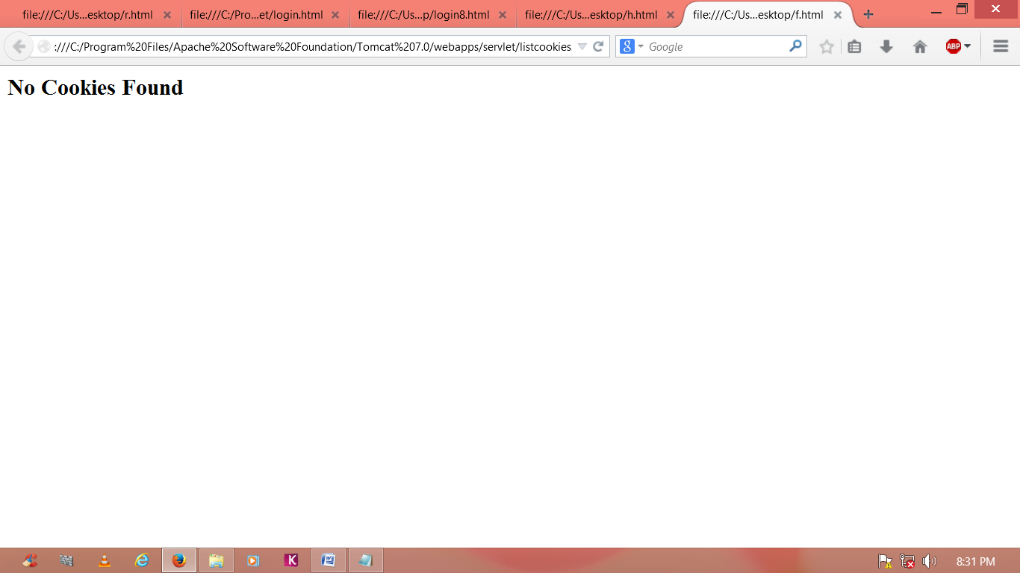

EXECUTED OUTPUT

15.4 VIVA QUESTIONS:
1. Define Cookies?
2. What is the use of response.addCookie( ).

ADD ON CONTENT
OBJECTIVE:
Develop static pages (using only HTML) of an online Book store. The pages should resemble: www.amazon.com. The website should consist the following pages.
- Home page
- Registration and user Login
- User profile page
- Books catalog
- Shopping cart
- Payment by credit card Order Conformation
SOURCE CODE:
Home page
Main.html
<html>
<head>
<title>Amazon</title>
</head>
<body bgcolor="cyan">
<center><strong><h1>Welcome to AMAZON</h1></strong>
<form method="post" action="login.html" target=_blank >
<h4>for books</h4><input type="submit" value="click here">
</form>
</center>
</body>
</html>
Registration and user Login
Login.html:
<html>
<head>
<title>login page</title>
</head>
<body bgcolor="cyan">
<center><strong><h1> AMAZON </h1></strong></center>
<right>
<table align="right">
<tr>
<td><h4>user name</td>
<td><input type="text" ></td>
<td></td>
</tr>
<tr>
<td><h4>password</td>
<td><input type="password"></td>
<td></td>
</tr>
<tr>
<td>
<form method="post" action="catalog.html" >
<input type="submit" value="submit" >
</form>
</td>
<td>
<form method="post" action="userpro.html" >
<input type="submit" value="register" >
&nbsp;&nbsp;
<input type="reset" value="reset"></form></td>
</tr>
</table>
</body>
</html>
User profile page
Userpro.html:
<html>
<head>
<title>login page</title>
</head>
<body bgcolor="cyan">
<center><strong><h1> AMAZON </h1></strong></center>
<form method="post" action="catalog.html" >
<right>
<table align="left">
<tr>
<td><h4>user name</td>
<td><input type="text" ></td>
</tr>
<tr>
<td><h4>password</td>
<td><input type="password"></td>
</tr>
<tr>
<td><h4>confirm password</td>
<td><input type="password"></td>
</tr>
<tr>
<td><h4>male &nbsp;&nbsp;
<option >
<input type="radio" name="sex" id="male"></td>
<td><h4>female &nbsp; &nbsp;
<input type="radio" name="sex" id="female" ></td>
</option>
</tr>
<tr>
<td>Address</td>
<td><textarea name="address" rows=5 cols=19>
</textarea>
</td>
<tr>
<td>
<input type="submit" value="submit" ></td>
<td>
<input type="reset" value="reset"></td>
</tr>
</body>
</html>
Books catalog

Catalog.html:

<html>
<head>
<title>books catalog</title>
</head>
<body bgcolor="cyan">
<center><h1>AMAZON</h1></center>
<form method="post" action="shopping.html">
<left>
<table>
<tr>
<td><b><h3>frontend books</td>
<td></td></tr>
<tr>
<td></td>
<td><h4>C&Ds</td>
</tr>
<tr>
<td></td>
<td><h4>Ads</td>
</tr>
<tr>
<td></td>
<td><h4>JAVA
</td></tr>
<tr>
<td><b><h3>backend books</td>
<td></td>
</tr>
<tr>
<td></td>
<td><h4>Oracle</td>
</tr>
<tr>
<td></td>
<td><h4>Ms SQL Server
</td></tr>
<tr><td><h4>MySql </td>
</tr>
</table>
</h4>
<center>
<b>for buy one of these books
<br>
</b><input type="submit" value="click here">
</center>
</form>
</body>
</html>

Shopping cart

Shopping.html:

<html>
<head><title>shopping cart</title>
</head>
<body bgcolor="cyan">
<center><h1>
Shopping Cart</h1></center>
<br><br><br><br><br>
<table align="center">
<tr>
<td>Text Books</td>
<td>
<select >
<optgroup label="select the book">
<option value="C&Ds">C&Ds
<option value="Ads">Ads
<option value="Java">Java
<option value="Oracle">Oracle
<option value="Ms SQL Server">Ms SQL Server
<option value="MySql">MySql
</optgroup>
</select>
</td></tr>
<tr>
<td>Quantity</td>
<td><input type="text" id="q"></td>
</tr>
<tr>
<td></td>
<td>
<form method=post action="payment.html">
<input type="submit" value=ok />
</form>
</td></tr>
</table>
<center>
<pre>Cost of one book is"500" + shipping "100"</pre>
</center>
<body>
</html>

Payment by credit card

Payment.html:

<html>
<head><title>payment</title></head>
<body bgcolor="cyan">
<center><h1>Payment By Credit Card</h1></center>
<form method=post action="ordrconform.html">
<br><br><br><br><br>
<table align="center">
<tr>
<td>
<h4>Total Amount</h4></td>
<td><input type="text">
</td>
</tr>
<tr>
<td><h4>Credit Card Number</td>
<td><input type="text"></td>
</tr>
<tr>
<td>
</td>
<td><input type="submit" value=OK>
</td>
</tr>
</table>
</form></body>
</html>
Order Conformation
Ordrconform.html:

<html>
<head><title>order conformation</title><M/head>
<body bgcolor="cyan">
<center>
<h1><b>BOOK SHOPPING</h1>
<pre><strong>
<b>Your order Is Conformed
</strong></pre>
<h2><b>THANK YOU</h2>
</center>
</body></html>

INPUT AND OUTPUT:

Main.html:
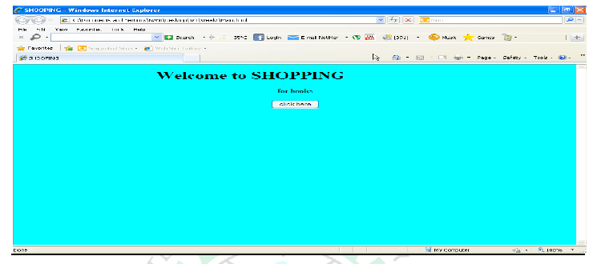
Login.html:
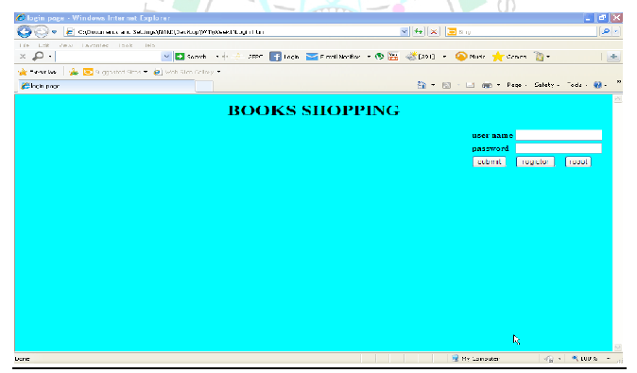
Catalog.html:
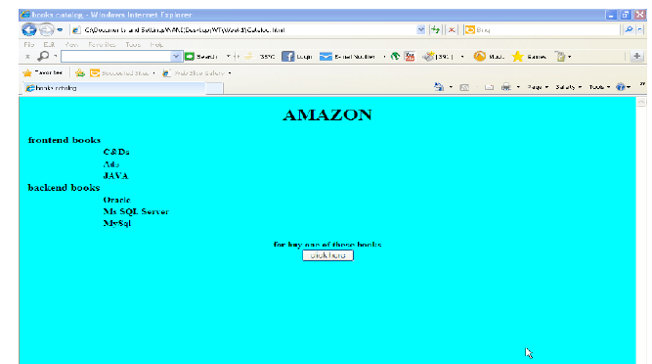

Userpro.html:

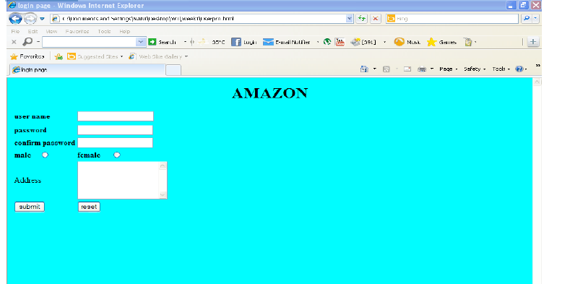

Shooping.html:
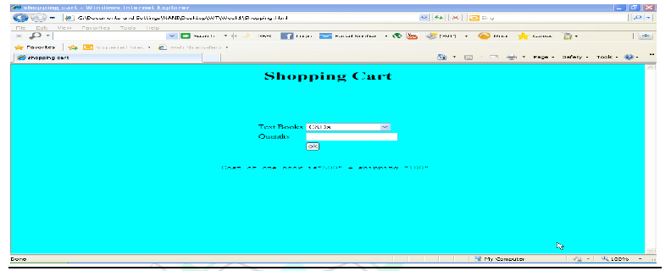

Payment.html:

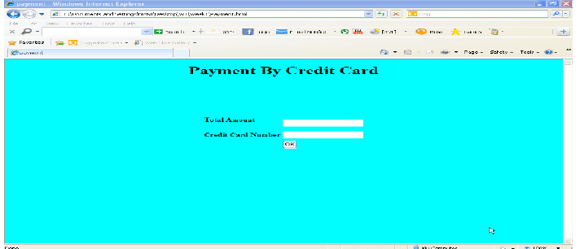

Ordrconform.html:
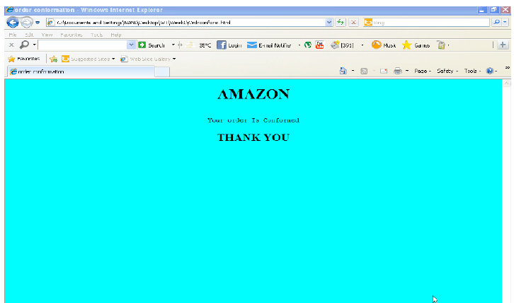

ADDITIONAL
PHP
PRACTICE PROGRAMS

Program No: 01
PHP Generate 10 Random Numbers Using Loop:
<?php

$min=10;

$max="100";
echo "Number between 10 to 100<br>"; for($i=0;$i<=10;$i++)
{
$r=rand($min,$max);

printf("Nnumber =%d<br>",$r);
}

?>

OUTPUT
Number between 10 to 100
Nnumber =28
Nnumber =77
Nnumber =38
Nnumber =76
Nnumber =49
Nnumber =27
Nnumber =53
Nnumber =27
Nnumber =87
Nnumber =89
Nnumber =22

EXECUTED OUTPUT

Program No: 02
PHP Multiplication Table Using Loop:
<?php

for($i=1;$i<=10;$i++)
{
for($table_counter=2;$table_counter<=5;$table_counter++)
{
printf("%d",($i*$table_counter)); echo " ";
if($table_counter==5)
{
echo "<br> ";
}
}
}

?>

OUTPUT

2 3 4 5
4 6 8 10
6 9 12 15
8 12 16 20
10 15 20 25
12 18 24 30
14 21 28 35
16 24 32 40
18 27 36 45
20 30 40 50

EXECUTED OUTPUT

